CROWD SIMULATION
CAPSTONE PROJECT PHASE-1
Phase – I Report
Submitted by

PRATHAM AMIT SINGH (22BCE10959)
ANSHUL DALVI (22BCE10799)
DEVDEEP NARAYAN (22BCE10407)
PIYUSH KUMAR (22BCE11141)
PRAGJYOTISH LAHAN (22BCE10725)

in partial fulfillment of the requirements for the degree of
Bachelor of Engineering and Technology



VIT Bhopal University
Bhopal
Madhyapradhesh

November, 2025



Bonafide Certificate

Certified that this project report titled “CROWD SIMULATION” is the Bonafide work of “22BCE10959 Pratham Amit Singh, 22BCE10799 Anshul Dalvi, 22BCE10407 Devdeep Narayan, 22BCE11141 Piyush Kumar, 22BCE10725 Pragjyotish Lahan” who carried out the project work under my supervision.

This project report (DSN4095-Capstone Project Phase-I) is submitted for the Project Viva-Voce examination held on …………..

Supervisor

DR. NILESH KUNHARE

Table of content

Sl.No. | Topic | Page No.
1. | Introduction
1.1 | Motivation
1.2 | Objective
2. | Existing Work
3. | Frontend, Backend and System Requirement
4. | Methodology
5. | Conclusion
6. | References

CHAPTER 1: INTRODUCTION

1.1 Motivation

Managing large crowds in real-world scenarios has become increasingly complex as public spaces continue to grow in scale, density, and activity. Human behaviour in groups is highly dynamic and often unpredictable, especially when individuals react differently under stress, urgency, or restricted movement. These variations make it difficult to anticipate how people will navigate through confined areas such as stadiums, malls, transport terminals, or during large public events.

Traditional planning and manual evaluation methods fail to capture the intricate interactions between individuals, obstacles, and available exits. As a result, crowd managers frequently struggle with issues such as bottlenecks, overcrowding, panic waves during emergencies, and inefficient use of physical space. The absence of reliable forecasting tools also increases the risk of delayed evacuation, injuries, or chaotic movement patterns during critical situations.

Crowd simulation offers a scientific and data-driven solution to these challenges. By modelling real-time movement, behavioural patterns, and spatial constraints, simulations help understand how people respond to different layouts and emergency conditions. The motivation behind this project is to create a realistic and analytical simulation system that can support safer infrastructure design, enhance evacuation planning, and improve decision-making for event organizers, urban planners, and disaster management authorities.

1.2 Objective

The primary objective of this project is to develop a simulation-based system capable of replicating realistic human crowd movement within enclosed or semi-structured environments. The goal is to create a model that accurately reflects how individuals navigate spaces, interact with surrounding obstacles, and respond to both normal and emergency conditions.
This project aims to identify and analyse critical factors such as congestion points, high-density zones, and natural bottlenecks that may hinder smooth flow. By computing movement patterns and estimating evacuation times, the system provides actionable insights that support the improvement of safety protocols and spatial design.
Another key objective is to offer clear and interactive visualizations of crowd behaviour, enabling stakeholders to observe crowd dynamics in real time. These visual outputs assist urban planners, event organizers, architects, and disaster management teams in evaluating layout efficiency, planning evacuation routes, and designing safer public spaces.
Overall, the project strives to create a practical decision-support tool that bridges computational modelling with real-world crowd management needs, ultimately contributing to more efficient, safer, and well-coordinated environments.

CHAPTER 2: EXISTING WORK/ LITERATURE REVIEW

Crowd simulation has been extensively studied across fields such as computer graphics, urban planning, AI, and behavioral science. Existing research broadly falls into five categories: social-force models, velocity-obstacle methods, agent-based models, cellular automata, and data-driven approaches. Each method attempts to reproduce realistic crowd behavior such as collision avoidance, lane formation, panic behavior, and evacuation patterns.

2.1 Social Force & Physics-Based Models
One of the earliest and most influential approaches is the Social Force Model (SFM) proposed by Helbing and Molnár [1]. In this model, pedestrians are treated as particles influenced by “forces” such as desired movement, interpersonal repulsion, and obstacle avoidance. Later, Helbing et al. demonstrated emergent panic behaviours such as crowd turbulence and clogging at exits [2].
Strengths
- Captures natural collective behaviours
- Suitable for emergency and evacuation modelling
Limitations
- Requires careful parameter tuning
- Can produce unrealistic overlap at high densities

2.2 Velocity-Obstacle & RVO Models
The Reciprocal Velocity Obstacles (RVO) method developed by van den Berg et al. [3] provides a geometric solution for collision-free navigation. Instead of force interactions, agents select velocities that avoid future collisions within a predicted time window. Because avoidance is “reciprocal,” agents produce smooth trajectories without oscillation.

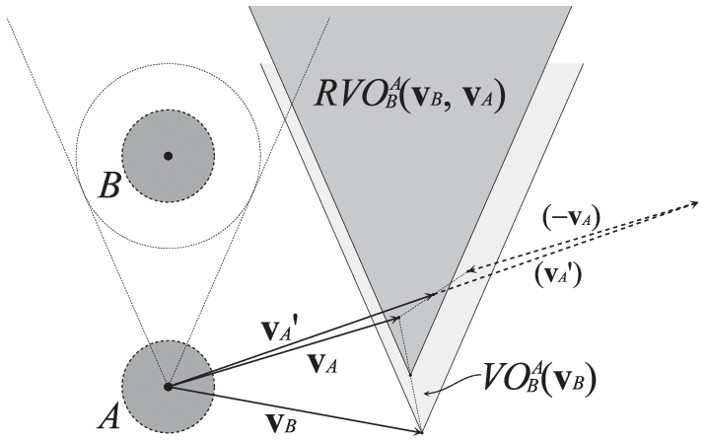
Figure 2.1: Illustration of the Reciprocal Velocity Obstacle (RVO) method used for local collision avoidance.
Strengths
- Highly efficient and real-time
- Widely used in games, VR, and crowd rendering
Limitations
- Mainly handles local navigation
- Needs a global planner for complex layouts

2.3 Agent-Based Behavioural Models
Agent-based models (ABM) focus on individual decision-making, psychological behaviour, and group dynamics. Recent surveys highlight extensions that incorporate emotional contagion, group cohesion, leader–follower dynamics, and vision-based interactions [4].

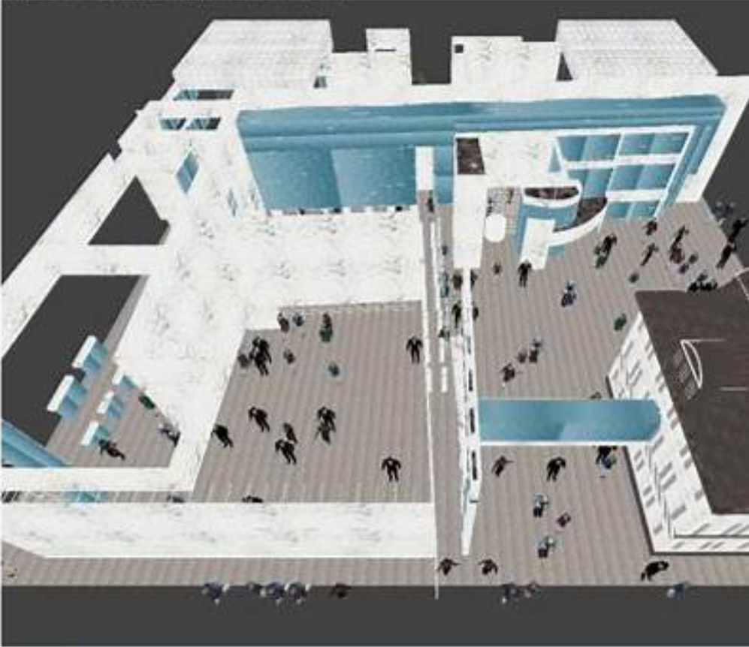
Figure 2.2:3D visualization of agent-based crowd simulation in a complex indoor environment.
Strengths
- Can represent heterogeneous populations
- Flexible and suitable for custom behaviours
Limitations
- Complex to calibrate
- Behaviour realism depends on detailed rules
2.4 Cellular Automata Models
Cellular Automata (CA) represent space as a grid where agents move between cells according to probabilistic rules [5]. CA models have been widely used for dense environments such as stadiums and railway stations.
Strengths
- Computationally simple
- Handles high crowd density well
Limitations
- Movement appears discrete or grid-like
- Requires rule adjustments for realism

2.5 Data-Driven & Learning-Based Methods
Recently, researchers have used video data, real-world trajectories, and deep learning to calibrate or learn crowd motion patterns. Techniques such as density map prediction, flow estimation and reinforcement learning allow simulations to match observed behaviour [6], [7].

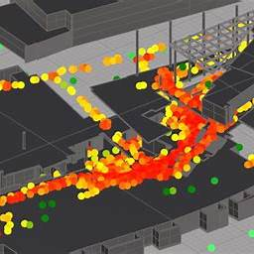
Figure 2.3: Example of a data-driven density heatmap commonly used for validating and analyzing crowd flow.

Strengths
- Better realism due to real-world calibration
- Useful for prediction and forecasting
Limitations
- Requires large datasets
- Generalization to new environments is difficult

2.6 Comparative Summary Table

Model Type | Description | Advantages | Limitations | References
Social Force | Physics-inspired forces determine movement | Realistic group behaviour | Sensitive to parameters | [1], [2]
RVO | Velocity-space collision avoidance | Real-time, smooth paths | Local minima issues | [3]
Agent-Based | Rule-driven autonomous agents | Expressive behaviours | High modelling effort | [4]
Cellular Automata | Grid-based movement | Simple & efficient | Grid artifacts | [5]
Data-Driven | Learns from real data | High realism | Data dependency | [6], [7]

(Table 1) Comparison of major simulation approaches.

2.7 Relevance to Present Project
The literature suggests that hybrid solutions combining distance-field global navigation, agent-based reasoning, and local collision avoidance (RVO/SFM) yield the most realistic results in evacuation scenarios.
Therefore, the present project adopts:
- Image Processing for detecting walls and exits
- Distance Field Navigation for global direction
- Agent Interaction Rules inspired by SFM/RVO
This aligns with established research trends and ensures both realism and computational efficiency.

List of figures
- Figure 1 (RVO / velocity-space illustration). Illustrates velocity obstacles and how the RVO cone excludes velocities that cause collisions; useful for explaining local collision-avoidance geometry.
- Figure 2 (3D visualization of agents in an interior). Demonstrates how agent-based simulations are visualized in design/VR tools for space planning.
- Figure 3 (Heatmap / flow visualization). Typical density/flow heatmaps used to detect bottlenecks and validate simulations against observations.
- Figure 4 (Distance transform / distance field maps). Distance fields are commonly used to compute shortest-field gradients to exits and guide agents (gradient-descent navigation).

CHAPTER 3: FRONT END, BACKEND AND SYSTEM REQUIREMENT
3.1 Relevance to Present Project
To implement an efficient and interactive crowd simulation system, the project is built using a clear separation between the frontend (visualization), backend (simulation engine), and the underlying system requirements (hardware and software). This architecture ensures modularity, scalability, and smooth performance when simulating large number of agents.
3.2 Frontend
The frontend provides all visual outputs and visual components that allow users to observe, manipulate, and analyze the crowd simulation.
3.2.1 Key Responsibilities
- Render real-time visualizations of the simulated crowd.
- Display environment layout, walls, exits, density maps and agent movement.
- Provide UI controls for:
  - Start / Stop simulation
  - Adjusting parameters (speed, population size, obstacle position, emergency mode)
  - Viewing analytics (congestion zones, heatmaps, evacuation time)
- Load maps or floor plans for simulation.
3.2.2 Technologies Used
- Matplotlib and Taichi GUI for rendering real-time movement of agents.
- OpenCV for image processing of layouts (walls/exits).
3.2.3 Frontend Features
- Dynamic rendering of crowd behavior.
- Visual indicators for:
  - Bottlenecks
  - High-Density Zones
  - Exits and paths
- Frame-by-Frame animation with adjustable speed
3.3 Hardware Requirements
3.3.1 Minimum Hardware
- Processor: Dual-core CPU (intel i3 / Ryzen 3 or equivalent)
- RAM: 4 GB
- Storage: 500 MB of free disk space
- GPU: Integrated graphics sufficient for small simulations
3.3.2 Recommended Hardware
- Processor: Quad-core CPU or higher
- RAM: 8 – 16 GB
- GPU: NVIDIA/AMD GPU for faster real-time simulation (as using Taichi for GPU rendering)
3.4 Software Requirements
3.4.1 Operating System
- Windows / Linums / Ubuntu (preferred for Python – based simulations)
3.4.2 Required Software and Libraries
- Python 3.10+
- NumPy
- OpenCV
- Matplotlib, Taichi

CHAPTER 4: METHODOLOGY
4.1 System Design / Architecture
The proposed methodology consists of three major components:
- Image Processing Module
- Agent-Based Simulation Module
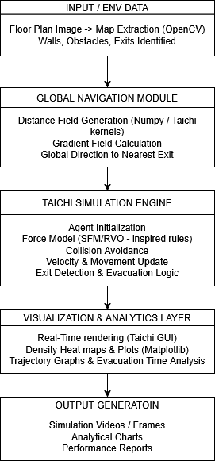
Figure 4.1: Overall System Architecture for Crowd Simulation
The architecture supports automated extraction of floor-plan features, generation of shortest-path navigation fields, and simulation of multi-agent movement.
4.2 Working Principle
4.2.1 Floor Plan Input and Preprocessing
The input floor-plan image undergoes several OpenCV operations such as grayscale conversion, thresholding, and contour extraction to detect walls and doors.
An example of processed layout extraction is shown below:
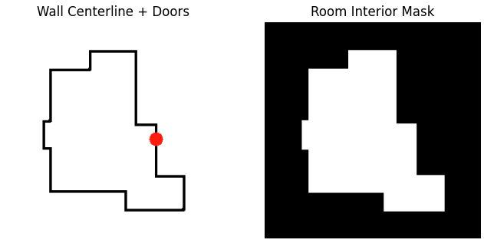
Figure 4.2: Example Extracted Architectural Boundary Using OpenCV
4.2.2 Distance Field Computation
A distance transform is applied on the walkable area to compute the shortest distance from all points to the nearest exit.
This global map guides all agents during movement.
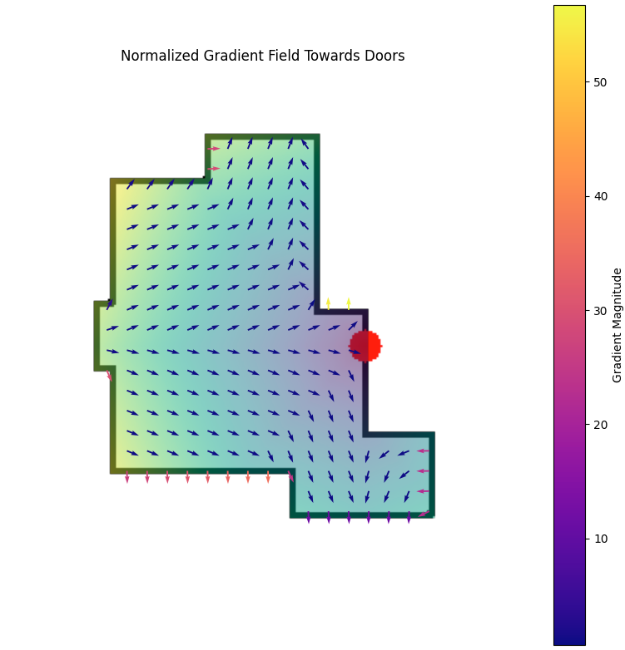
Figure 4.3: Distance Field Visualization for Pathfinding
4.2.3 Initialization of Agents
Agents are randomly assigned positions in the walkable area. Each agent is initialized with:
- Speed
- Personal space radius
- Collision-avoidance strength

4.2.4 Agent Movement Simulation
Agents follow the negative gradient of the distance field to move toward the exit. Local collision avoidance ensures smooth flow.
To illustrate the simulation environment, a 3D visualization of crowd dynamics is shown below:

4.3 Results and Discussion
4.3.1 Boundary & Distance Field Accuracy
The extracted wall/door boundaries closely match the actual structure of the input layout (refer Fig. 4.2), and the distance field helps agents use shortest paths (refer Fig. 4.3).

4.3.2 Crowd Movement Results
The simulation replicates realistic behaviours such as:
- Formation of queues near exits
- Congestion at narrow passages
- Faster evacuation in wide-exit scenarios
A summary of sample test results is shown below:
Table 4.1: Example Simulation Results for Different Scenarios
Scenario | No. of Agents | Exit Width | Avg. Evacuation Time (sec) | Bottleneck Detected
Scenario 1 | 50 | 1 m | 28.4 | Yes
Scenario 2 | 100 | 2 m | 35.2 | Moderate
Scenario 3 | 150 | 3 m | 40.5 | No

4.4 Individual Contribution

1. Pratham Amit Singh (22BCE10959)
Pratham played a key role in developing the image processing pipeline, which serves as the foundation of the entire simulation workflow. He worked on floor-plan preprocessing, applying grayscale conversion, noise reduction, contour extraction, and wall/door segmentation using OpenCV. His contributions ensured that all architectural elements—such as boundaries, obstacles, and exits—were extracted with high accuracy. He also developed the binary navigable map that functions as the primary input for the distance field computation module.
Additionally, Pratham focused on optimizing image processing operations to reduce computational overhead and make the pipeline suitable for real-time simulation. He improved detection stability across different floor-plan formats and handled edge cases such as incomplete contours and irregular shapes. Alongside implementation, he contributed significantly to methodology documentation, making the system design and image processing workflow clear and easy to understand.

2. Anshul Dalvi (22BCE10799)
Anshul was responsible for the development of the distance field computation module, which determines the optimal navigation paths for all agents in the simulation. He implemented the distance transform algorithm, integrated it with the extracted layout, and refined the gradient computation that agents follow to reach exits. His work ensured that shortest-path navigation occurred naturally without relying on complex pathfinding algorithms. He also performed validation tests to confirm that the distance fields responded correctly to structural changes such as narrow corridors or multiple exits.
In addition, Anshul coordinated closely with the image processing and simulation teams to maintain compatibility across modules. He fine-tuned parameters to improve gradient smoothness and reduce navigation noise, ensuring agent movement remained stable and realistic. His analytical approach helped identify errors early in development, making the overall system more robust and reliable.

3. Devdeep Narayan (22BCE10407)
Devdeep led the implementation of the agent-based simulation system, designing the core logic that determines agent behaviour and movement. He developed the functions responsible for gradient-based navigation, wall avoidance, and inter-agent repulsion, ensuring the simulation mimicked realistic human crowd dynamics. His work allowed agents to move independently yet respond intelligently to their surroundings, producing emergent patterns such as queuing and lane formation.
He also conducted multiple scenario tests using different agent densities and behaviour parameters, helping refine the movement model. Devdeep resolved issues related to agent clustering, overlapping, and stagnation zones, improving the reliability and smoothness of crowd movement. His contributions form the interactive backbone of the project, enabling realistic visualization of crowd evacuation behaviour.

4. Piyush Kumar (22BCE11141)
Piyush contributed extensively to testing, validation, and performance evaluation of the simulation. He designed structured test cases to assess evacuation times, congestion levels, and the system’s response to variations in exit width and crowd density. His work provided crucial insights into system behaviour, confirming that the simulation aligned with established crowd modelling principles. He also compiled the results into clear metrics and tables that support the project’s analysis.
Beyond testing, Piyush performed stress-tests to measure the simulation’s performance at higher agent counts and under constrained exit conditions. His observations helped identify bottlenecks in the system and guided optimization efforts. He also assisted in generating visual graphs and comparative summaries for the Results and Discussion section, contributing significantly to the analytical depth of the project.

5. Pragjyotish Lahan (22BCE10725)
Pragjyotish was primarily responsible for visualization and documentation, converting simulation outputs into clear and meaningful representations. He created detailed visualizations for boundary extraction, distance-field maps, and agent movement sequences, ensuring each stage of the simulation was thoroughly documented. These visuals were instrumental in explaining the system’s functionality during reviews and in the final report.
He also played a major role in preparing and refining the project documentation, ensuring consistency, clarity, and proper formatting throughout the report. Pragjyotish worked on organizing figures, captions, and layout flow, making the technical content more accessible to readers. His efforts strengthened the presentation quality of the project, both in written and visual form.

CHAPTER 5: CONCLUSION

The development of the crowd simulation model has demonstrated the potential of computational techniques in understanding and predicting human movement within enclosed environments. By integrating image processing, distance field computation, and agent-based simulation, the system successfully transforms a static floor plan into a dynamic virtual environment capable of representing realistic crowd behaviour.

The simulation accurately identifies key evacuation factors such as congestion zones, bottlenecks, exit utilization, and movement patterns, providing a clear visualization of how different architectural layouts influence overall crowd flow. The results highlight the importance of strategic exit placement, room geometry, and crowd density in ensuring efficient and safe evacuations.

This project not only provides a functional prototype for analysing crowd dynamics but also establishes a scalable foundation for future enhancements. With further refinement, the system can be extended toward real-time monitoring, integration with AI-based behaviour models, and support for complex multi-storey or outdoor environments. Overall, the work completed in this phase demonstrates that simulation-driven approaches can significantly assist architects, planners, and safety authorities in making informed decisions that enhance public safety and spatial efficiency.

References

[1] D. Helbing and P. Molnár, “Social force model for pedestrian dynamics,” Phys. Rev. E., 1995.

[2] D. Helbing, I. Farkas, T. Vicsek, “Simulating dynamical features of escape panic,” Nature, 2000.

[3] J. van den Berg, M. Lin, D. Manocha, “Reciprocal Velocity Obstacles for Real-Time Multi-Agent Navigation,” ICRA, 2008.

[4] S. Khan et al., “Agent-Based Crowd Simulation: A Comprehensive Survey,” 2024.

[5] S. Yang, “A review of crowd simulation and modelling,” 2020.

[6] F. Makinoshima et al., “Crowd flow forecasting using observation-driven agent models,” Scientific Reports, 2022.

[7] Deep learning-based crowd behaviour and density prediction studies (general dataset-driven research).

